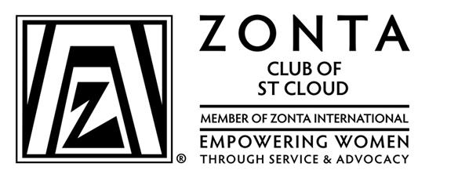

YES! I/Our company wants to support efforts on behalf of the District 7 conference in September, with excess revenue to be donated to the Zonta Foundation for Women (Rose Fund) and/or to the Zonta Foundation for Women (Endowment Fund) -- to be determined by the District 7 Executive Board.

Your sponsorship at one of the following levels would greatly serve our District 7 needs:
**(If you want to make an anonymous donation, please make a note to that request on this form.)

- Gold Level $ 500 contribution _______
- Silver Level $ 250 contribution _______
- Bronze Level $ 125 contribution _______
- Other (such as swag for the swag bags, in-kind services)
Call Debra Kellerman 218-689-4892 for information _______

Name of Individual/ Company_________________________________________Club______________________________

Address ____________________________________________________________________________

Phone Number _______________________________ Email __________________________________

Contact Person ______________________________________________________________________

Make your check payable to Zonta Club District 7 and
Send your contribution to Jackie Forck, D7 Treasurer
3523 Amazonas Drive
Jefferson City, MO 65109

Please respond by August 16, 2021 so we can acknowledge you in the program, signage at the conference, on the District 7 conference page on the website, etc.

Thanks for your generous support!

